All meetings are normally open to the Public and Press

I HEREBY GIVE NOTICE THAT THE ANNUAL MEETING OF THE MAIDEN BRADLEY WITH YARNFIELD PARISH COUNCIL WILL BE HELD ON Tuesday 27th JUNE 2023 AT 7.00PM – MAIDEN BRADLEY VILLAGE HALL

PUBLIC PARTICIPATION

Members of the public and press are entitled to attend the meeting unless the Parish Council by resolution enters confidential session. Within this public session, members of the public may make representations, ask, and answer questions and give evidence on any matter affecting or of concern, by addressing the Chairman. Members of the public are requested to raise any matter during this session as the rest of the meeting is not open to public participation.
AGENDA

23/24 001 ELECTION OF CHAIRMAN
To elect a Chairman for this municipal year. Upon his/her election, the Chairman will be invited to formally subscribe a declaration of acceptance of that office.

23/24 002 ELECTION OF VICE CHAIRMAN
To elect a Vice Chairman for this municipal year. If appointed, upon his /her election, the Vice Chairman will be invited to formally subscribe a declaration of acceptance of that office.

23/24 003 WELCOME & APOLOGIES
To consider any apologies for absence.

23/24 004 PARISH COUNCIL MEMBERSHIP
a. To receive any updated Register of Interests.
b. To consider Councillors responsibilities to oversee the following:
Community and Tourism Currently Cllr Bridgen
Defibrillator Currently Cllr Bridgen
Financial Checks/ Parish Steward oversight Currently Cllr Seymour
Footpaths/Signage Currently Cllr Halligan
Intermediary for Estate Currently Cllr Seymour
Litter Pick Currently Cllr Stancomb
Recreation Ground Currently Cllr Wager / Cllr Barrass proposed
Highways/Traffic/SID Currently Cllr Wager
Other items to cover

23/24 005 DECLARATIONS OF INTEREST
To DECLARE interests, RECEIVE written dispensation requests for items of disclosable pecuniary interest and GRANT requests where appropriate. Under the Parish Council’s Code of Conduct in accordance with the Localism Act 2011 and The Relevant Authorities (Disclosable Pecuniary Interests) Regulations 2012,SI No. 1464.

23/24 006 CONFIRMATION OF MINUTES
To receive minutes of the Parish Council Meeting held in May 2023. To recommend these are approved as a correct record and agreement given for them to be signed by the Chairman.

23/24 007 CHAIRMAN’S REPORT / INTRODUCTION
To receive a short introduction from the newly appointed Chairman.

23/24 008 PLANNING MATTERS FOR CONSIDERATION
Update on applications from last meeting where appropriate: None Received

To consider the following planning applications: None Received.

23/24 009 FINANCES
Bank Mandate update from Clerk

To present current financial statement and balance on accounts – Balance on accounts showing as £36931.29 as at 31st May 2023

RFO advised that the precept of £14310.13 received as installment 1 from Wiltshire Council.

To agree schedule of payments as indicated below:
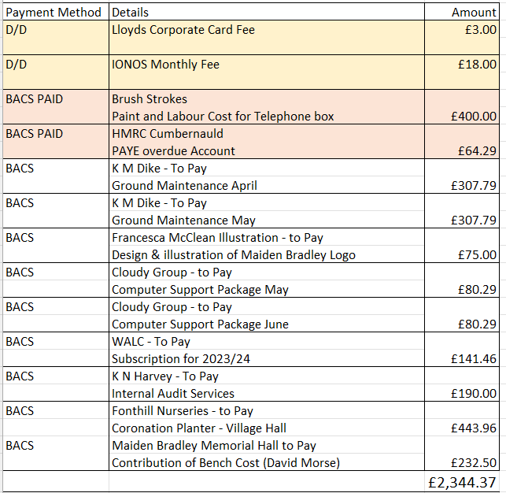

To receive YE End Accounts signed by RFO

To receive Internal Auditor Report and as a result Sign off Annual Governance Return for 2022/23

To set period of Public inspection : recommend 3rd July to 11th August 2023.

To update councillors on Clerks hours since start date.

23/24 010 TO RECEIVE REPORTS ON COUNCILLOR RESPONSIBILITES
To receive Report from Wiltshire Councillor Cllr Parkes

Areas of responsibility All Councillors

23/24 011 OTHER BUSINESS REFERRED TO THE CLERK
Finger Post Refurbishment – Cllr Wager
Removal of Saplings re noticeboard – Cllr Bridgen
Reduction in Yew Trees on the Knapp – Cllr Bridgen
Request for Signposts Church Farm – Cllr Halligan
Suggestions from new Clerk – Grant application scheme (attached), Website, others.
23/24 012 CORRESPONDENCE
Idverde – Litter Pick general information of supporting litter pick events/ Educational opportunities.

Carriageway Repair works - on Gare Hill Road, Maiden Bradley with Yarnfield, Warminster. These works involve asphalt patch repairs, adjustment of ironwork, reinstatement of road markings and associated maintenance works. The works will completed on Wednesday the 28th of June 2023 between the hours of 07:00 and 19:00,
Shearwater Parking – For information only
23/24 013 DATES OF FURTHER MEETINGS
To agree Full Council meeting dates for the coming year including:

Half yearly budget considerations (suggested September) and the 2024 Annual Parish Meeting (suggested May 2024)

Close

