+

Maiden Bradley with Yarnfield Parish Council



9 Beech Grove, Warminster, Wiltshire, BA12 0AB Tel: 01985 213436

Chairman: Councillor Simon Wager Clerk: Mrs Sarah Jeffries PSLCC

# All Parish Council Meetings are open to the Public and Press

**Tuesday 28th of February 2023**

# To All Members of Maiden Bradley with Yarnfield Parish Council Staffing Committee

Dear Councillor,

You are summoned to a meeting of Maiden Bradley with Yarnfield Parish Council Staffing Committee, at Maiden Bradley Village Hall on **Tuesday 28th February 2023 at 6.30pm.** The meeting will consider the items set out below.

If any members of the public wish to attend and make a statement or raise a question at the meeting, they should contact the Clerk before the meeting email [clerk@maidenbradley-pc.gov.uk](mailto:clerk@maidenbradley-pc.gov.uk) or phone 07540611906. The Clerk will then guide you with the process the meeting will take and assist you with any GDPR requirements you might have.

Council is asked to note that in the exercise of their functions they must take note of the following: Equal opportunities (race, gender, sexual orientation, marital status, and any disability; Crime and Disorder, Health and Safety and Human Rights).

Before the meeting there will be a public session to enable the people of Maiden Bradley to ask questions of, and make comments, regarding the Parish Council. Questions not answered at this meeting will be answered in writing to the person asking the question or may appear as an agenda item for the next meeting. Members of the public are asked to restrict their comments, and/or questions to three minutes.

Photographing, recording, broadcasting, or transmitting the proceedings of a meeting by any means is permitted under the openness of local Government Regulations 2014 (England Only). A person may not orally report or comment about a meeting as it takes place if he is present during the meeting of a parish council or its committees but otherwise may:

Film, photograph or make an audio recording of a meeting.

Use any other means for enabling persons not present to see or hear proceedings at a meeting of a parish council as it takes place or later.

Report or comment on the proceedings in writing during or after a meeting or orally report or comment after the meeting.

However, anyone wishing to do so must speak to the Clerk prior to the meeting as there is policy and General Data Protection Regulations 2018 which must be followed.

Any person who may find difficulty in access to the meeting through disability is asked to advise the Clerk (07540 611906) or 01985 213436 email address ([clerk@maidenbradley-pc.gov.uk](mailto:clerk@maidenbradley-pc.gov.uk) ) at least 24 hours before the meeting so that every effort may be made to provide access.

Sarah Jeffries PSLCC

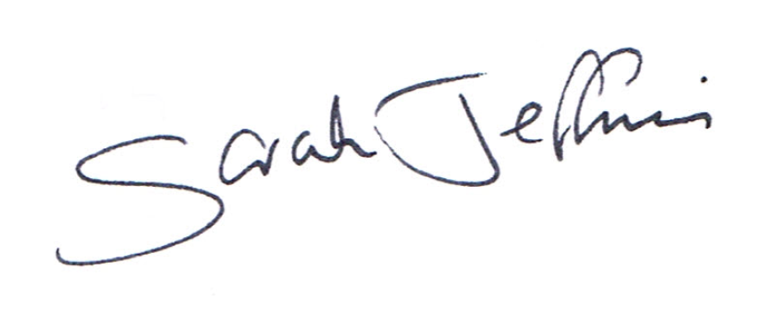

Parish Clerk

Wednesday 22nd of February 2023

# 6.30pm Public Question Time

This section (at the Chairman’s discretion may last up to 15 minutes) is not part of the formal meeting of the Council and minutes will not be produced. Public Bodies (admissions to meetings) Act 1960 s 1 extended by the LG Act 1972 s 100.

**Agenda**

# 1. Acceptance of apologies for absence

Schedule 12 of the Local Government Act 1972 requires a record to be kept of the members present and that this record form part of the minutes of the meeting. Members who cannot attend a meeting should tender apologies to the Parish Clerk as it is usual for the grounds upon which apologies are tendered also to be recorded. Under Section 85(1) of the Local Government Act1972, members present must decide whether the reason(s) for a member's absence are accepted.

# 2. Dispensations

Council is asked to discuss any written requests for dispensation the Clerk may have received from Councillors.

# 3. To receive declarations of interests Local Authorities

Declarations of Interest members to declare any interest they may have in agenda items that accord with the requirements of the relevant authorities (Disclosable Pecuniary Interests) Regulations 2012 (SI 2012/1464) (NB this does not preclude any later declarations).

# 4. Exclusion of the Press and Public Standing Order #1c

The Parish Council may exercise their right to exclude the public and press by resolution from a closed meeting due to the confidential nature to be discussed pursuant to section 1(2) of the Public Bodies (Admission to Meetings) Act 1960.

Council is asked to discuss excluding the Press and public for any item listed on the below Agenda.

# 5. Chairmans Announcements.

# 6. Interview Questions

The Staffing Committee is asked to discuss the draft questions prepared and the scoring matrix provided. Council is asked to confirm to the Clerk any alterations or additions required to the documentation.

# 7. Selection Process/ Feedback to unsuccessful Candidates

The Staffing Committee is asked to discuss which Councillor will action the selection process and send out the invitations to those selected following the closing date of the 12th of March 2023.

The below actions will need to be followed.

* Applications once received are distributed to the selection panel.
* A list of applications judging their suitability is selected.
* A shortlist of the candidates is agreed by email and those candidates invited for an interview.
* Contact the unsuccessful candidates and action the job offers. The Chairman should write to the successful candidate within 3 days of the panel confirming the offer of the role including the essential terms of the offer, salary, hours, holiday, etc.

(A contract of employment must be provided to the successful candidate before or on the first day of employment).

The Clerk will provide the selected Councillor with the Parish Council Laptop so they can action the above and communicate with the applicants. (This item is to be approved by Full Council)

# Locum Clerk

Council is asked to note that should it not find a suitable Clerk it can contact the Society of Local Council Clerks and arrange for a Locum Clerk until the position is filled. This additional cost would need to be approved by Full Council before the Staffing Committee proceeded. See below information and link:

Z

<https://www.slcc.co.uk/locum-interim-services/>

## SLCC Need someone to stand in temporarily?

Sometimes councils find themselves in need of a temporary clerk or additional staff resource, be that as a result of illness, maternity or paternity cover, holidays, vacancies, increased workloads or one-off projects. Whatever the reason, LCC can help by providing experienced, qualified staff for both short and long-term placements.

Our services are delivered by our team of locums, all of whom have the knowledge and skills to provide the support you need. They are employed by SLCC, and your council is invoiced for the number of hours worked at the agreed hourly rate, enabling the council and locum to comply with HMRC off-payroll rules. The rate charged is inclusive of Employers National Insurance, our payroll and handling costs and a payment for annual leave, making the locum process easy for you to manage.

Depending on the hourly rate the locum would charge LCC, costs range from £25 per hour upwards (an all-inclusive charge). The hourly rate is often more than that of permanent staff due to the nature of the work and the flexibility offered, but in return you have a trained individual who is ready to hit the ground running. They are able to deal with complex situations and impart new skills and processes as a result of their placement, bringing added benefit to the council and public they serve.

If you would like to find out more or have a need for a clerk or additional resource, please contact us at locum@slcc.co.uk and we can talk through the process and work to find you a solution.

Councillors are asked to note that in the exercise of their functions they must take note of the following: Equal opportunities (race, gender, sexual orientation, marital status, and any disability); Crime and Disorder, Health and Safety and Human Rights. Any person who may find difficulty in access to the meeting through disability is asked to advise the Clerk (07540 611906) or 01985 213436 email ([clerk@maidenbradley-pc.gov.uk](mailto:clerk@maidenbradley-pc.gov.uk) ) at least 24 hours before the meeting so that every effort may be made to provide access.