M I N U T E S
Of the Annual Council Meeting Held 27th June 2023
At Maiden Bradley Village Hall 7pm

Present: Chairman Cllr Wager, Cllrs Brigden, Seymour, Halligan, Swan, Barrass

Also Present: Wiltshire Councillor Parkes, J Gregory – Clerk, plus 2 members of the public.

Public Participation.
The public raised two matters:
- 20 mph at Randalls (noted as ongoing)
- High Street signage (also ongoing)

23/24 001 Election of Chairman
Cllr Brigden took the Chair indicating that Cllr Wager was prepared to stand for the 1 year term.
Resolved: All members voted unanimously for Cllr Wager as Chairman. An Acceptance of Office form was duly signed.

23/24 002 Election of Vice Chairman
The Chairman, Cllr Wager proposed Cllr Brigden for the post, who was happy to stand.
Resolved: All members voted unanimously for Cllr Brigden as Vice Chairman. An Acceptance of Office form was duly signed.

23/24 003 Welcome and Apologies
The Chair welcomed everyone to the meeting, it was nice to see members from the village in attendance.

Apologies were received from Cllr Stancomb who had work commitments and could not attend.
Resolved: Apologies received and accepted from Cllr Stancombe

23/24 004 Parish Council Membership
To receive any updated Register of Interests
Resolved: There was nothing further from Councillors to amend their Register of Interests.

To update Councillor responsibilities:
The following responsibilities were allocated:
Community and Tourism Cllr Brigden
Defibrillator Cllr Brigden
Financial Checks/Parish Steward oversight Cllr Seymour
Footpaths and signage Cllr Halligan
Intermediary for the Estate Cllr Seymour
Litter Pick Cllr Stancomb
Recreation Ground Cllr Barrass
SID/Traffic/Highways Cllr Wager

23/24 005 Declarations of interest
Received at appropriate juncture: Cllr Seymour declared an interest in 23/24 008 and refrained from voting. Cllr Swan declared an interest in 23/24 007 and took no part in any decision making.

23/24 006 Minutes of the Previous Meeting
Minutes of the May full Council meeting were received by the meeting.
Resolved: Duly approved by all members in attendance and signed by the Chairman in the presence of the Clerk.

23/24 007 Chairman’s Report / Introduction
The Chairman advised that the Council had gone through a difficult period however recruitment of a Clerk was now complete and a warm welcome expressed to Jen Gregory. Jen was also clerk at a number of Somerset parishes.

Traffic signage drawings for the rank was circulated to members and discussion ensued. It was noted that the signage had been drawn up by the Traffic Engineer and was funded from Section 106 monies therefore there was no cost to the Parish. On review there were two amendments.
Resolved: Council unanimously agreed the signage proposal with the following amendments: removal of the hatched area to the rank and removal of a chevron on the bend of Bradley Lane (up to the Quarry). Cllr Parkes would take this forward with some urgency.

The Chair advised that he had unearthed reasons for the warning letter not being actioned in the 20mph zone – this was due to the fact that speeding in this area goes direct to Court as a result CSW are not working in this area.

The Chair said that the grant offer to organisations would be done at the next meeting as there was an emphasis and indeed requirement this meeting with passing financial matters.

23/24 008 Planning Matters for consideration
PL/2023/04314 Manor Farm, Maiden Bradley
Change of Use – agricultural to flexible commercial use (antique furniture storage and distribution)
Following discussion regarding usage and traffic it was noted that this was a renewal of an existing application as the 3 year planning requirement was expiring. There was, for reference, no retail or showroom within this application.
Resolved: Members (less Cllr Seymour) voted to recommend approval of this application.

23/24 009 Finances
The Clerk stated that emergency action needed to be taken to allow changes to the mandate in order to reconcile the year end. As a result the “key contact” at Unity Bank was amended to reflect changes in clerk.

The current financial statement as at 31st May 2023 was £36931.29. This included a stage 1 payment of precept of £14310.13 from Wiltshire Council.

The following payments were submitted for reference and approval:
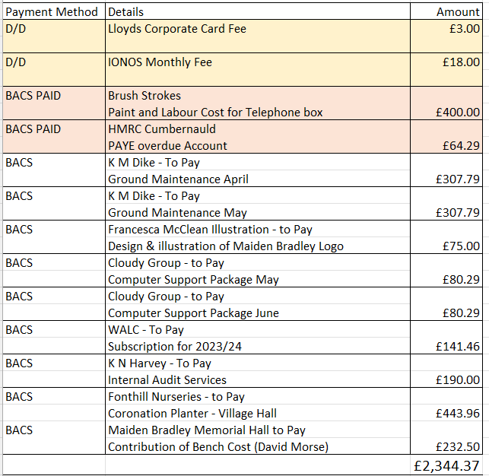
Resolved: This was agreed with the exception of Francesca McClean noting this had already been paid via Cllr Seymour

A Financial statement and Year end Accounts to 31st March was produced by the Clerk. In summary income totalled £30070.00 mainly due from a precept of 26k, expenditure totalled £25899.56 with the biggest spends as you would expect in salary, office expenses and ground maintenance. Grants were made in the sum of £2700. Finally, the carry forward figure into 2023/24 financial year was a healthy £23895.68
Resolved: The Council unanimously approved the Financial Statement/Accounts and AGAR for the year ending 31st March 2023 which was duly signed in the presence of the Clerk.

An internal audit report was summarised to the meeting. The main points to note that in some months an incorrect bank figure was given as part of the reconciliation and should not be signed off. Robust processes for negating financial impropriety was noted along with annual reviews of policies and procedures. The internal Auditor was comfortable in signing off the Annual Governance Statement as a result.

The Clerk advised that the Council needed to set a period of inspection of accounts. The recommendation was from the 3rd July to 11th August 2023
Resolved: Period of inspection noted and would be duly advertised via noticeboards in the village and via the website.

The Clerk advised that whilst her contracted hours were 5 hours per week. Since her commencement (30.05.23) and including this week would be in the region of 30 hours which in affect was an hour a week over the contractual requirement.
Resolved: Council noted the extra work involved in the initial stages and was happy to pay this amount on receipt of a submitted timesheet.

23/24 010 To Receive Reports on Councillor Responsibilities
Wiltshire Cllr Parkes gave a summary of activities as follows along with extending any offer of help to the Clerk which was gratefully received.
- Rights of way 8 posts at Church Farm – being chased
- The Highway Improvement Group with Cllr Wager was looking at: traffic calming (Mere) problem with vehicles short cutting Back Lane and reapplying the 20mph area and setting up of the new SID
- The B3092 surface was breaking up and being looked at.
- There had been a cautiously optimistic meeting on Friday regarding the A350/A303 concept.
- The Highways new contractor Milestone was in place who had taken over from Ringway. Cllr Seymour expressed a number of difficulties with the Stewardship (silt being dug out but not removed from the area and following rainfall this washed back down to the drain). gullies on Church Street and blocked drains. Cllr Parkes would engage the factoring crews for this work. He noted the stewardship problems and would feed this back.

Cllr Barrass indicated that prior to the new clerk there was some contract negotiation needed regarding grass cutting that hadn’t been actioned. This problem was echoed by Cllr Swan who queried the amount of cuts being made as currently the Recreation Ground and Knapp was looking quite shabby.
Action: Cllr Barrass was tasked with obtaining quotations and looking at requirements generally with the contractor regarding grass cutting.

23/24 011 Other Business Referred to the Clerk
Finger Post refurbishment had been agreed and a resident from the Village would carry this out.

Cllr Brigden felt that the Yew Tree (with the two pronged trunk) on the Knapp needed attention as looking up at the canopy this was edging out other trees.
Action: Cllr Barrass to action with advice (and quotations if necessary) being sought.

The noticeboard area had saplings growing with dumped dead grass behind it and was unsightly.
Action: For Cllr Wager / Barrass to obtain quotations including suggestion to ask Paul Hughes (Gardiner)

Requests from signposts Church Farm – Covered in 23/24 010

Suggestions from the clerk:
Website: The Clerk felt that the website just carried too much irrelevant information, looked messy and was off putting with lots of pdf’s all listed down pages. She had instigated a new website for Witham Friary PC – this was perhaps a good starting point. It was logical, relevant and had a community section to reflect the vibrancy and diversity of the village groups without being overly cumbersome and messy to look at.
Action: Clerk to look at costs and options including Mr/Mrs Lavender within the village.

Corporate Credit Card: The Council were using a corporate card for the IONOS website payment. She felt that this unnecessary and was clocking up a monthly payment for something that could be moved to Direct debit and ultimately if we changed the website would not be required.
Action: To move IONOS to a Direct debit system pending any decision regarding the website

Grants process: to allow the council to properly budget, meet expectations of groups and be more transparent in what money they are giving and the benefit it was suggested that a Grants form be adopted. This was deferred for agreement at the next meeting. But suggested amounts were £500 with the deadline being end of September which would tie in with budget arrangements.
Action: Deferred agreement to next meeting

23/24 012 Correspondence
The following correspondence was duly noted:

Idverde – litter pick general information of support

Carriageway repairs – Gare Hill Rd Wednesday 28th June between 7am and 7pm

Shearwater parking – Complaint made to Cllr Parkes and subsequent action with relevant enforcement agencies advised.

23/24 013 Dates of Further Meetings
Full council meetings would be held bi-monthly on the first Tuesday of the month – the next meeting being 5th September. At this meeting grants not given this meeting would be considered along with half yearly budget considerations.

The Annual Parish meeting would be pencilled in for May 2024.

The Chairman thanked everyone for their attendance and contribution. The meeting closed at 7.55pm

A copy of the signed minutes is available via the Clerk on request. An unsigned version will be posted on the website and noticeboard.

