+

Maiden Bradley with Yarnfield Parish Council



9 Beech Grove, Warminster, Wiltshire, BA12 0AB Tel: 01985 213436

Chairman: Councillor Simon Wager Clerk: Mrs Sarah Jeffries PSLCC

# All Parish Council Meetings are open to the Public and Press

**Tuesday 24th of January 2023**

# To All Members of Maiden Bradley with Yarnfield Parish Council Staffing Committee

Dear Councillor,

You are summoned to a meeting of Maiden Bradley with Yarnfield Parish Council Staffing Committee, at Maiden Bradley Village Hall on **Tuesday 24th January 2023 at 7.00pm.** The meeting will consider the items set out below.

If any members of the public wish to attend and make a statement or raise a question at the meeting, they should contact the Clerk before the meeting email [clerk@maidenbradley-pc.gov.uk](mailto:clerk@maidenbradley-pc.gov.uk) or phone 07540611906. The Clerk will then guide you with the process the meeting will take and assist you with any GDPR requirements you might have.

Council is asked to note that in the exercise of their functions they must take note of the following: Equal opportunities (race, gender, sexual orientation, marital status, and any disability; Crime and Disorder, Health and Safety and Human Rights).

Before the meeting there will be a public session to enable the people of Maiden Bradley to ask questions of, and make comments, regarding the Parish Council. Questions not answered at this meeting will be answered in writing to the person asking the question or may appear as an agenda item for the next meeting. Members of the public are asked to restrict their comments, and/or questions to three minutes.

Photographing, recording, broadcasting, or transmitting the proceedings of a meeting by any means is permitted under the openness of local Government Regulations 2014 (England Only). A person may not orally report or comment about a meeting as it takes place if he is present during the meeting of a parish council or its committees but otherwise may:

Film, photograph or make an audio recording of a meeting.

Use any other means for enabling persons not present to see or hear proceedings at a meeting of a parish council as it takes place or later.

Report or comment on the proceedings in writing during or after a meeting or orally report or comment after the meeting.

However, anyone wishing to do so must speak to the Clerk prior to the meeting as there is policy and General Data Protection Regulations 2018 which must be followed.

Any person who may find difficulty in access to the meeting through disability is asked to advise the Clerk (07540 611906) or 01985 213436 email address ([clerk@maidenbradley-pc.gov.uk](mailto:clerk@maidenbradley-pc.gov.uk) ) at least 24 hours before the meeting so that every effort may be made to provide access.

Sarah Jeffries PSLCC

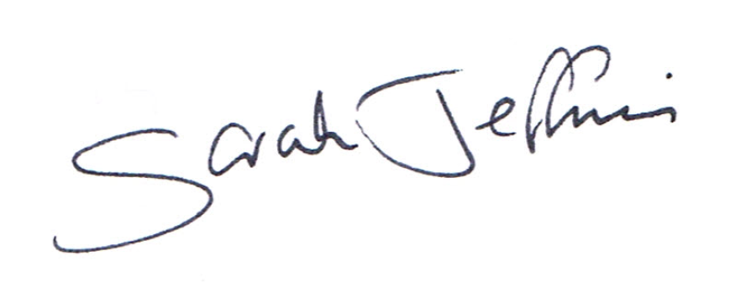

Parish Clerk

Wednesday 18th of January 2023

# 7.00pm Public Question Time

This section (at the Chairman’s discretion may last up to 15 minutes) is not part of the formal meeting of the Council and minutes will not be produced. Public Bodies (admissions to meetings) Act 1960 s 1 extended by the LG Act 1972 s 100.

**Agenda**

# 1. Acceptance of apologies for absence

Schedule 12 of the Local Government Act 1972 requires a record to be kept of the members present and that this record form part of the minutes of the meeting. Members who cannot attend a meeting should tender apologies to the Parish Clerk as it is usual for the grounds upon which apologies are tendered also to be recorded. Under Section 85(1) of the Local Government Act1972, members present must decide whether the reason(s) for a member's absence are accepted.

# 2. Dispensations

Council is asked to discuss any written requests for dispensation the Clerk may have received from Councillors.

# 3. To receive declarations of interests Local Authorities

Declarations of Interest members to declare any interest they may have in agenda items that accord with the requirements of the relevant authorities (Disclosable Pecuniary Interests) Regulations 2012 (SI 2012/1464) (NB this does not preclude any later declarations).

# 4. Exclusion of the Press and Public Standing Order #1c

The Parish Council may exercise their right to exclude the public and press by resolution from a closed meeting due to the confidential nature to be discussed pursuant to section 1(2) of the Public Bodies (Admission to Meetings) Act 1960.

Council is asked to discuss excluding the Press and public for any item listed on the below Agenda.

# 5. To receive and sign the minutes of the meeting held on 10th January 2023 (Previously circulated) LGA 1972 Sch 12 para 41(1)

# 6. Chairman’s announcements

# 7. Clerks Resignation

The Staffing Committee is asked to note the Clerks resignation. (The Clerks contract states two months’ notice is to be given).

# 8. Job Description and Salary Scale

The Staffing Committee is asked to discuss the recommendations regarding the Job Description and the Salary Scale points it can consider.

Carry out a review of the role. To include

1. Determine whether the job is the same as when the incumbent was recruited
2. Do we need someone with the same knowledge, skills, and experience as last time?
3. Are the terms and conditions still suitable?
4. Review whether the hours are set at the right level to get the job done?
5. Review and amend as necessary the current job description

Only when the above is complete should an advertisement be created.

The Role

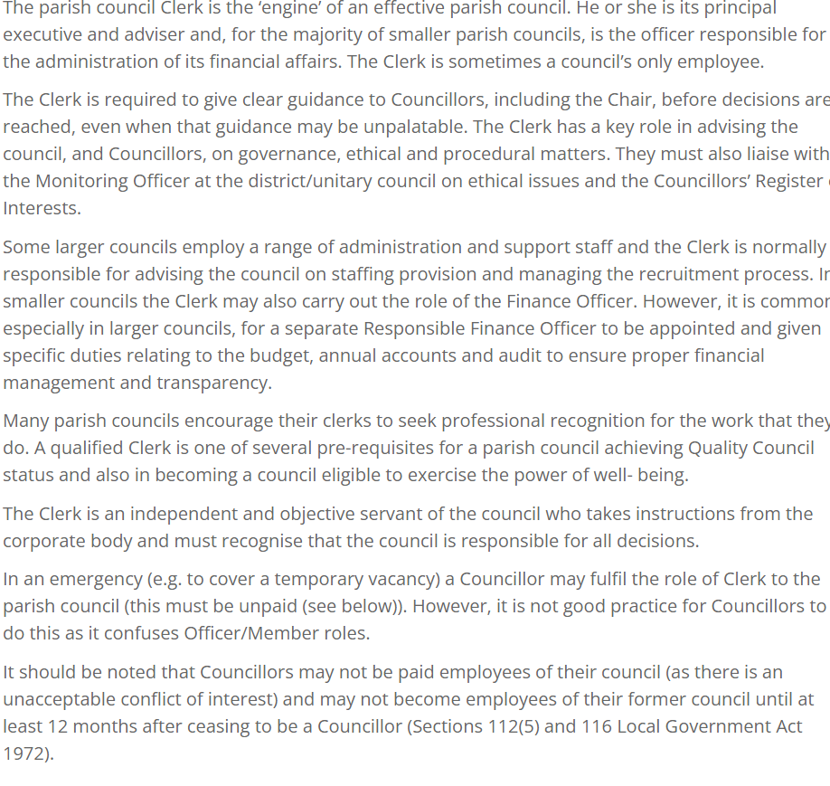

# 9. Recruitment Action/Advertisement

The Staffing Committee is tasked to discuss the recommendations regarding the recruitment of the new Clerk. Where it will advertise, and the content of the advert.

* Wiltshire Association of Local Councils – As members this would be free
* Society of Local Council Clerks – See attached costings
* Warminster Journal – costs depending on size and content
* Blackmore Vale - costs depending on size and content

A closing date for applications will also be required and to whom applications are to be sent and processed by.

**10. Interviews**

The Staffing Committee is asked to confirm where the interviews will be held and whom of the Staffing Committee will be on the interview panel.

# 11. Selection Process/ Feedback to unsuccessful Candidates

The Staffing Committee is to discuss the selection process:

* Applications once received are distributed to the selection panel
* A list of applications judging their suitability is selected
* A shortlist of the candidates is agreed, and those candidates invited for an interview
* A set of questions will need to be agreed to probe job skills and qualities essential for the job, so each interviewee is asked the same.
* Each Member of the panel will need to keep clear notes and score each interviewee on a score sheet.
* Based on the interview scores each member of the panel should nominate their preferred interviewee. The successful interviewee is the one with two of the panels vote.
* Who will contact the successful/ unsuccessful candidates and action the job offers.

(The Chairman should write to the successful candidate within 3 days of the panel confirming the offer of the role including the essential terms of the offer, salary, hours, holiday, etc) A contract of employment must be provided to the successful candidate before or on the first day of employment.

The Staffing Committee is asked to set the starting date for the new Clerk and who will action the handover. (Parish Council equipment and documentation)

# **12. Notice of items to be taken into consideration at the next meeting in February.**

Councillors are asked to highlight any further items. If Councillors have been approached by parishioners with an issue/item for Council to investigate, please can Councillors complete an Agenda item reporting form and send it to the Clerk within six clear days of the next meeting. If Councillors wish motions to be included on the next Agenda, they need to be sent to the Clerk before the 2nd of February 2023 as per Standing Orders). See below:

# Standing Orders 9. Motions for a meeting that require written notice to be given to the Proper Officer

A. A motion shall relate to the responsibilities of the meeting for which it is tabled and, in any event, shall relate to the performance of the Council’s statutory functions, powers and obligations or an issue which specifically affects the Council’s area or its residents.

B. No motion may be moved at a meeting unless it is on the agenda and the mover has given written notice of its wording to the Proper Officer at least (6) clear days before the meeting. Clear days do not include the day of the notice or the day of the meeting.

C. The Proper Officer may, before including a motion on the agenda received in accordance with standing order 9(b), correct obvious grammatical or typographical errors in the wording of the motion.

D. If the Proper Officer considers the wording of a motion received in accordance with standing order 9(b) is not clear in meaning, the motion shall be rejected until the mover of the motion resubmits it, so that it can be understood, in writing, to the Proper Officer at least (4) clear days before the meeting.

E. If the wording or subject of a proposed motion is considered improper, the Proper Officer shall consult with the chairman of the forthcoming meeting or, as the case may be, the councillors who have convened the meeting, to consider whether the motion shall be included in the agenda or rejected.

F. The decision of the Proper Officer as to whether or not to include the motion on the agenda shall be final.

# 13. Items for Parish Newsletter & Notice Boards

The Staffing Committee are asked to inform the Clerk which items it wishes her to highlight in the parish news from the meetings minutes.

# 14. Date of the next meeting

The Staffing Committee is asked to note that **Tuesday 22nd of February 2023** at 7.00pm is the date of the next Full Council meeting. All are welcome to attend.

Councillors are asked to note that in the exercise of their functions they must take note of the following: Equal opportunities (race, gender, sexual orientation, marital status, and any disability); Crime and Disorder, Health and Safety and Human Rights. Any person who may find difficulty in access to the meeting through disability is asked to advise the Clerk (07540 611906) or 01985 213436 email ([clerk@maidenbradley-pc.gov.uk](mailto:clerk@maidenbradley-pc.gov.uk) ) at least 24 hours before the meeting so that every effort may be made to provide access.