All meetings are normally open to the Public and Press

I HEREBY GIVE NOTICE THAT FULL COUNCIL MEETING OF THE MAIDEN BRADLEY WITH YARNFIELD PARISH COUNCIL WILL BE HELD ON TUESDAY 5TH SEPTEMBER AT 7.00PM – MAIDEN BRADLEY VILLAGE HALL

PUBLIC PARTICIPATION

Members of the public and press are entitled to attend the meeting unless the Parish Council by resolution enters confidential session. Within this public session, members of the public may make representations, ask, and answer questions and give evidence on any matter affecting or of concern, by addressing the Chairman. Members of the public are requested to raise any matter during this session as the rest of the meeting is not open to public participation.
AGENDA

23/24 014 WELCOME & APOLOGIES
Welcome from the Chair and to consider any apologies for absence.

23/24 015 PARISH COUNCIL MEMBERSHIP /DECLARATIONS OF INTEREST
To DECLARE interests, RECEIVE written dispensation requests for items of disclosable pecuniary interest and GRANT requests where appropriate. Under the Parish Council’s Code of Conduct in accordance with the Localism Act 2011 and The Relevant Authorities (Disclosable Pecuniary Interests) Regulations 2012,SI No. 1464.

23/24 016 CONFIRMATION OF MINUTES
To receive minutes of the Parish Council Meeting held in June 2023. To recommend these are approved as a correct record and agreement given for them to be signed by the Chairman.

23/24 017 PLANNING MATTERS FOR CONSIDERATION
To consider the following planning applications:
Premises Licence Application:
Post office, Church Street
For the sale of alcohol Sun 10.00-22.00, Mon- Sat 8.00-22.00
Recorded Music Mon-Sat 8.00-22.00
Deadline for response 19th September 2023

Planning Committee Minutes of 27.07.23 available on Request.

23/24 018 FINANCES
To present current financial statement and balance on accounts – Balance on accounts showing as at 31.07.23 £32651.67

To agree schedule of payments as indicated below: (pink indicates authorised payments during July when Council did not meet).
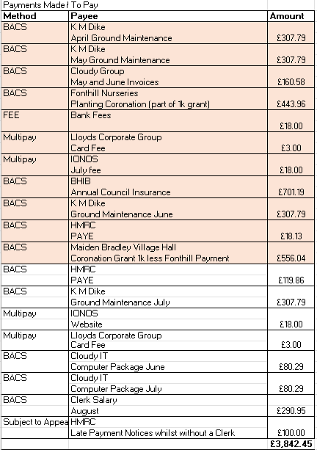

23/24 019 TO RECEIVE REPORTS ON COUNCILLOR RESPONSIBILITES
To receive Report from Wiltshire Councillor Cllr Parkes

Areas of responsibility All Councillors as below where appropriate and not included in 23/24 020:

Community and Tourism Cllr Bridgen
Defibrillator Cllr Bridgen
Financial Checks/ Parish Steward oversight Cllr Seymour
Footpaths/Signage Cllr Halligan
Intermediary for Estate Cllr Seymour
Litter Pick Cllr Stancomb
Recreation Ground Cllr Barrass
Highways/Traffic/SID Cllr Wager

23/24 020 OTHER BUSINESS REFERRED TO THE CLERK
The Knapp
Clearance and removal of undergrowth around fence lines and trees. Including growth around PC notice board
Removal of stunted growth tree
Truncation and or possible removal of Yew Tree.
Arboreal work to be carried out to improve existing important trees
Examine and replace existing fencing around the knapp
Tidy up around the back of the bus stop. Future of bus stop
Grass cutting contract. 2024
Bulb Planting request
Jubilee Trees.
PC to take responsibility for Jubilee Tree area including maintenance and upkeep
Fencing of area as per the Knapp
Bench Seating.
Appropriate signage and notice board
Grass cutting contract. 2024
Recreation Ground
Update from Councillor Tyler Barrass on plans for upgrading facilities and maintenance and future of the recreation ground
Grass cutting contract. 2024
Church Railings
Future Maintenance of railings at present being painted.
Traffic
LH FIG Applications (CATG)
Removal of traffic pinch point B3092 by the Old Vicarage
Installation of suitable mounting post for CID in the above area
Metro count for Kingston Lane and Back Lane
RE examination of application for 20mph speed limit
Kingston Lane and Back Lane
Other Traffic Matters.
High Street resurface and apply 20mph roundels upgrade and correct roadside signage.
Incomplete road resurfacing Church Street
Quotation for SID Received
The Rank
Agree and apply upgrade of required signage. Using an agreed funding. ( Bill Parks)
Community Speed Watch
Update on activity to date including traffic flow overview.
Future of CSW and its effect on traffic through Maiden Bradley
Grant Scheme
To adopt Grant Scheme forms / Policy as per attached
Other
Replacement/upgrading of Village Brown signs
23/24 021 CORRESPONDENCE
Website quotations (2) for consideration
Corporate Card update
23/24 022 DATES OF FURTHER MEETINGS
Next meeting 7th November 2023 to include budget and precept setting.

Close

