# 9 Maiden Bradley with Yarnfield Parish Council

9 Beech Grove, Warminster, Wiltshire, BA12 0AB Tel: 01985 213436

Chairman: Councillor Simon Wager Clerk Mrs. Sarah Jeffries PSLCC

# Minutes of the meeting of Maiden Bradley with Yarnfield Parish Council held on Tuesday 8th November 2022 at 7.00pm.

**Present:** Councillors, Simon Wager, Susanna Brigden, Sebastian Seymour, Esther Swan, and Ann-Marie Halligan.

**In attendance:** The Parish Clerk, Mrs. Sarah Jeffries PSLCC, Unitary Councillor Bill Parks and two parishioners.

## 

## **Public Question Time** Public Bodies (admissions to meetings) Act 1960 s

## Public Bodies (admissions to meetings) Act 1960 s 1 extended by the LG Act 1972 s 100.

A parishioner spoke to Unitary Councillor Bill Parks about the Church railings. He reported that the listings of the Church railings are being investigated by the Wiltshire Council Team, it was noted that they are in a conservation area. He mentioned that planning was required for any alterations and that the PCC will need to action this. It was mentioned that companies are able to empty porta loos via VAC tubing and so mitigating the need for the railings to be altered, he would obtain details of these companies and pass it onto the parishioner.

A parishioner spoke about the Old Timber Yard; Developers offer to provide a village shop. They explained that they had met with the developer and wish to open a privately owned shop rather than a Community run shop. The advertisement of the developers offer was mentioned and concern that the Community needed to be behind the venture. It was felt that an article in the Parish News would be the best way of informing the Community. Unitary Councillor Bill Parks reported that he asked the Wiltshire Council Business, Economy and Enterprise Team if there was grant funding available but sadly there is none available this year but this might change next year.

The Warminster Area Board meeting was mentioned and that a brief was being given from the Weight Watchers Group.

The Chairman thanked him for coming

# 22/155 Acceptance of apologies for absence

Schedule 12 of the Local Government Act 1972 requires a record to be kept of the members present and that this record form part of the minutes of the meeting. Members who cannot attend a meeting should tender apologies to the Parish Clerk as it is usual for the grounds upon which apologies are tendered also to be recorded. Under Section 85(1) of the Local Government Act1972, members present must decide whether the reason(s) for a member's absence are accepted.

**Resolved:** noted none given, as all Councillors were present.

# 22/156 Dispensations

**Resolved:** none requested.

# 22/157 to receive declarations of interests Local Authorities

Declarations of Interest members to declare any interest they may have in agenda items that accord with the requirements of the relevant authorities (Disclosable Pecuniary Interests) Regulations 2012 (SI 2012/1464) (NB this does not preclude any later declarations).

**Resolved:** notednone given.

# 22/158 Exclusion of the Press and Public Standing Order #1c

The Parish Council may exercise their right to exclude the public and press by resolution from a closed meeting due to the confidential nature to be discussed pursuant to section 1(2) of the Public Bodies (Admission to Meetings) Act 1960.

**Resolved:** not required.

# 22/159 To receive and sign the minutes of the meeting held on 25th November 2022 (Previously circulated) LGA 1972 Sch 12 para 41(1)

**Resolved:** agreed that they were a true record of the meetings decisions. Proposed Councillor Esther Swan Seconded CouncillorSusanna Brigden.

# 22/160 Chairman’s announcements

**Resolved:** noted he had none to give.

# 22/161 Co-option

**Resolved:** Councillors Susanna Brigden, Esther Swan and Ann-Marie Halligan took the leaflets to be circulated in the parish. The Clerk was instructed to email co-option form to Councillor Milena Stancomb for a possible candidate. The Clerk would seek clarification of their eligibility for office when their application form was received.

# 22/162 Planning

**Resolved:** noted that at the time of producing this Agenda there were no planning applications received for Council to comment on.

**(Please note in planning matters the Council acts as the consultee of the Principal Authority. The Principal Authority being the deciding body, Parishioners can make their comments directly to the Principal Authority)**

# 22/163 Planning Decisions

**Resolved:** noted the below decisions made by Wiltshire Council.

**Application Ref PL/2022/07626 - Householder Application**

**Address: 58 the Rank, Bradley Lane, Maiden Bradley, Warminster, BA12 7JF**

**Proposal: Alterations and rear 2 storey extension.**

**Decision:** to be made on the 28th November 2022

**Sydenh**am’s Site Bill Board Frames

**Resolved:** noted the below research Unitary Councillor Bill Parks had actioned regarding the Councils request for further information on the Bill board frames at the development.

Development Signs

I have spoken to Planning Officers then to the Enforcement Team about the Sydenham’s development. They have pointed me towards the ‘Outdoor advertisements and signs guide for advertisers’ (copy attached). There are regulations on sizes of signs that can be erected – re page 15, Class (3).

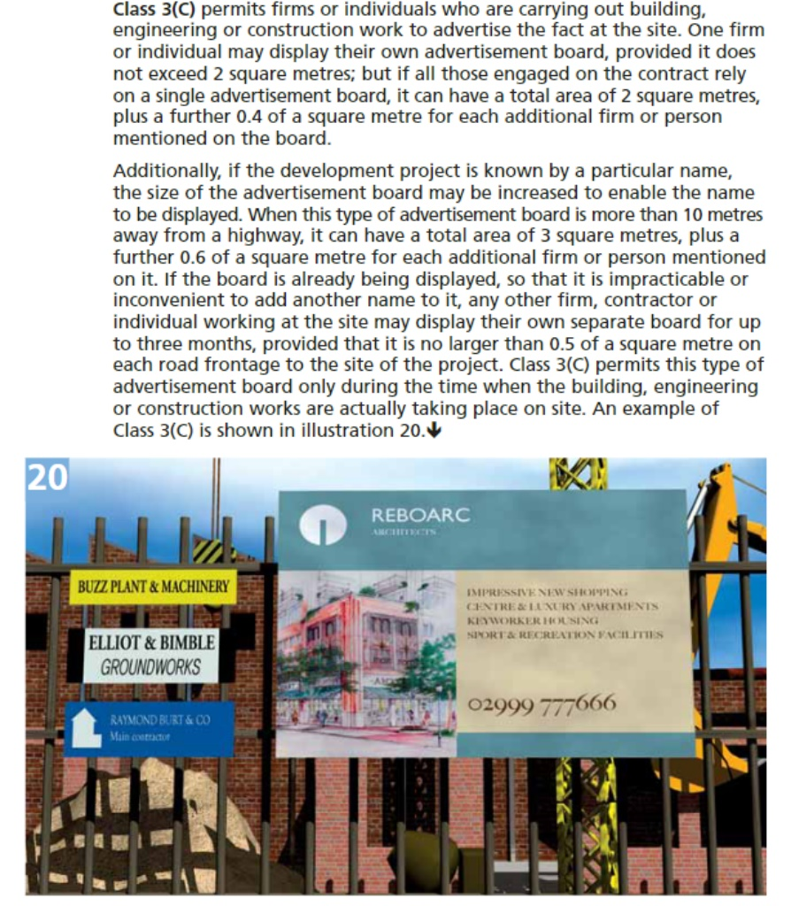

If there is concern then it should be brought to the attention of enforcement@wiltshire.gov.uk that will check it out and take any appropriate action. Usually, any problems are resolved amicably with the Developer.

# 22/164 Street Naming

**Resolved:** noted that the Clerk had informed the Developer and Wiltshire Councils Street Naming Team, of the Council’s comments.

# 22/165 Parish Steward

**Resolved:** Councillor Sebastian Seymour reported that thepavement cleaning and inside of the Church railings had been requested but the Parish Steward had reported to him, that he had had an incident with a lorry outside of the public house, so these had not been completed.

It was agreed that for his next visit that Back Lane and Kingston Lane gullies/drains were cleaned out, post flooding. The signage on Bradley Lane and Horningsham Lane be cleaned and cleared of foliage around the NFU Mutual Offices. It was also asked if the Church Street pavement clearing be completed.

# 22/166 Church Railings

**Resolved:** noted that further damage has occurred to the railings. Councillor Simon Wager has brought this to the attention of the Highways Team, who are organising them to be repaired yet again.

Council noted that the Clerk had sought Unitary Councillor Bill Parks comments re the Wiltshire Council asset, see below:

I have looked at the conservation mapping for the village. All Saints Church is listed and the railings lie in the village conservation area but I can’t determine with certainty that the railing are listed.

Any damage to the railing requires bespoke pieces to be cast which can be expensive so I wouldn’t encourage the village to seek an asset transfer.

Also damage that arises from road traffic accidents entails a lengthy process of recovering costs from the insurance company.

Temporary Traffic lights can be hired from a company of which there are many. (I can give names as required) However, all works on the Highway require-

•Formal authorisation is required for any promoter wishing to use Portable Traffic Signals on the highway

•It is an offence to place and operate Portable Traffic Signals on the highway without approval from the Highway Authority as given in Traffic Signs regulation and general Directions 2002 Part 11 Direction 53

Further information can be found here Highway licences – click on below link:

[Highway licences - Wiltshire Council](https://www.wiltshire.gov.uk/licences-permits-highways)

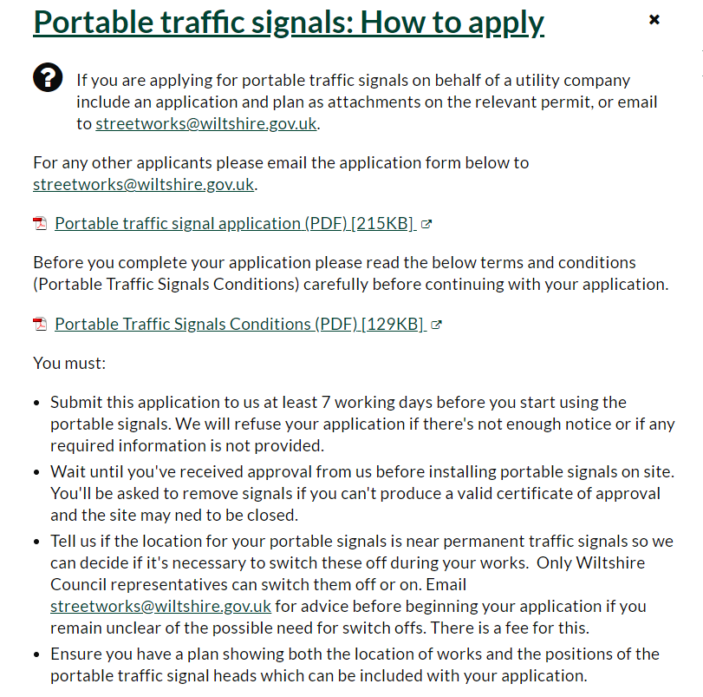

# It was agreed that a meeting would be arranged by the Chairman with the PCC and the Highways Team.

# 22/167 Traffic Calming and Speeding Traffic - Action Plan Transport & Traffic

# Speed Indicator Device

**Resolved:** noted the quotation for two SIDs presented. The Clerk was directed to add the cost to the draft budget, for budgeting purposes. Councillors were unanimous that this was included as a cost.

# Community Speed Watch Volunteers

**Resolved:** Councillor Simon Wager reported on the activities of the Community Speed Watch Volunteers. Teams were dwindling but two groups were still very active.

# 22/168 Sydenham’s Timber Yard – New Village Shop

**Resolved:** noted the Clerk had informed the Developer and Wiltshire Councils Street Naming Team of the Parish Councils comments.

# 22/169 Recreational Area Health & Safety

**Resolved:** noted the monthly Health & Safety check report actioned on the play equipment by Councillor Simon Wager and that Hippo caps were to be replaced.

# 22/170 Village Hall – Action Plan Local Economy and Tourism

**Resolved:** Councillor Susanna Brigden reported that she had not been able to go to the meeting; she will circulate the minutes when received.

# 22/171 Action Plan – The Church (support efforts to mobilise volunteers)

**Resolved:** Councillor Milena Stancomb reported on her interaction with the Parochial Church Council.

A choir had been assembled, it had moved out of the Church to a private house as it was too cold but it has since sadly disbanded. They have been invited to sing at Bradley House and will be reforming just for this event. Councillor Milena Stancomb mentioned groups she had researched, Eco Church Living and Church’s caring for god’s acres; she is interested in these two groups and bringing local small group churches together to support each other. The Chairman thanked her for her report back.

# 22/172 Defibrillator

**Resolved:** Councillor Susanna Brigden confirmed she had actioned the Defibrillator checks to the Council and that she has provided a copy of notification of the report this month to the Clerk.

# 22/173 Rights of Way

**Resolved:** Councillor Ann-Marie Halligan reported that the group has been working hard getting the facts and figures for their proposal. They hope to have this already for the beginning December. Councillor Sebastian Seymour reported that the estates will discuss the action when the report is received.

# 22/174 Annual Newsletter

**Resolved:** noted that the Clerk awaiting the photograph from Councilor Susanna Brigden. Councilor Susanna Brigden apologies and stated she would email the Clerk a picture for use.

# 22/175 Accessible Image of the Council

**Resolved:** Councillor Susana Brigden mentioned the red kite with some landscape shown below cross roads with the red kite flying above it would make an excellent image. It was agreed that the Artist to be approachedfor a quote, all agreed.

Councillor Susanna Brigden and the Clerk to move it forward to a quotation stage for the next meeting.

(The Parish Council owns the Interpretation Board graphics copy, so one quotation could only be sought in this instance).

**22/176** Internal Audit Check

**Resolved:** Councillor Sebastian Seymour reported that he had actioned the check before the meeting and no issues were found. The Chairman thanked him.

# 22/177 Budget Preparations Council to agree its objectives for next year

**Resolved:** instructed theClerk to take the following into consideration when preparing the Draft Budget.

* A contractor re painting the telephone box
* Graphics re the accessible Image of the Council
* The full s137 allowance

(The Action Plan will direct Council as to the funding required to complete the requests from the Community).

**Precept Request following the agreed budget**

**Resolved:** noted the below information sent by the Wiltshire Council Finance Team

**Council Tax Factsheet for Town and Parish Councils**

What is the tax base? This is the average number of band D equivalent properties within your town/parish.

How the tax base is calculated - The tax base is produced from the council tax system. This produces a listing of all the properties in each town/parish, per the Valuation Office records we receive, which is then adjusted to take into account any discounts that are given, for example, single occupancy, second homes, homes that are empty or exempt etc.

The properties are then translated into band D equivalent’s using the required ratios below:

Band A 6/9 Band B 7/9

Band C 8/9 Band D 9/9 (1)

Band E 11/9 Band F 13/9

Band G 15/9 Band H 18/9 (2)

Finally, we add on an estimated number of band D equivalents to be built in the year and apply a collection rate adjustment. This then gives us the total number of band D equivalent properties to use for the tax base.

What is the tax base used for? The tax base is used to calculate the band D charge for each town/parish. This is done by dividing the total precept requirement by the tax base. This figure will be compared to the previous year’s band D charge and published on the Council’s website.

A common query is when the parish have set their precept at the same monetary value as the previous year but find that their charge per band D property has gone up. This will be due to the tax base having gone down i.e. the number of properties we can collect from has gone down.

Why might the tax base go down? The tax base could go down due to more properties in that town/parish claiming for discounts, most commonly an increase in the number of properties claiming single occupancy discount. Other factors include homes being demolished, becoming empty, becoming second homes, boundary changes, a change to the collection rate adjustment or an increase in the number of people claiming benefits.

Where significant changes are not understood, Wiltshire Council can provide a summary of the movement in a town/parish tax base by comparing last year’s report to this year’s report.

When will the tax base be issued for 2023/2024? This will be sent out by Monday 7 November 2022.

Precept calculator tool

A simple tool is available on the Wiltshire Council website. It’s a quick and easy tool that you can use to:

Find out the effect of changing the precept by a certain amount and/or

Find out the effect of changing the precept by a certain percentage

Please be aware that the tool does not yet contain 2023/2024 data. This will be updated in early November 2022. A separate e-mail will be circulated when it becomes available and will include a reminder of your town/parish login details.

Deadline for confirmation of your precept requirement

The deadline for precept requirements is 18 January 2023. This is to ensure that all the data is available for setting the council tax which is done by the middle of February. Council tax cannot be set without precept requirement confirmation from all town/parish councils, Police and Fire Authorities and Wiltshire Council. The law requires that a town/parish must confirm even when the precept is nil.

A delay in council tax setting has a massive impact on billing to the public and payment of precepts. It is imperative that towns/parish arrange their budget setting meetings appropriately so that they can meet the precept requirement deadline.

Payment of precept

Providing the precept requirement deadlines have been met precepts will be paid as follows:

Towns/Parishes with a precept under £10k will receive their full precept by the end of April.

Towns/Parishes with a precept greater than £10k will receive half of their precept by the end of April and the other half by the end of September.

How will the precept be paid?

Payment will be made by BACS directly into the town/parish bank account. Any changes to bank account must be notified on headed paper to:

Wiltshire Council

Business Services Accounts Payable

PO Box 4385

Bythesea Road

Trowbridge, Wiltshire

BA14 4DS

Updating contact details

Any changes to contact name, address, telephone number or e-mail address should be notified to the following e-mail address

committee@wiltshire.gov.uk

An internal process is in place to ensure the financial system is then also updated.

Who can sign the precept request?

The precept should be approved at the town/parish council’s appropriate budget setting committee and a record kept of the approval. The precept request form should ideally be authorised at that meeting by the council’s chair. However, we will also accept the signature of the clerk of the council and for 2023/2024 we will also accept an e-mailed submission from the contact e-mail address we hold.

Towns with a precept greater than £140,000

If a town/parish has a precept requirement greater than £140,000 you are required to provide a breakdown of expenditure and income to the public. Towns and parishes required to do this will be contacted individually with a request to collect this information to be published on the council’s website.

If your precept requirement is likely to be greater than £140,000 for the first time, please contact us.

# **22/178 Approval and signing of Parish Accounts for the month of October 2022** Internal Audit Accounts & Audit Regulations 2003 reg 2

**Resolved:** approved the accounts for October 2022. Noted the Clerks report that the Unity Trust Bank balance as of the 31st October 2022 was £34,796.51.

# **22/179 Payments** LGA 1972 s150 (5)

**Resolved:** reviewed and approved the items of expenditure listed below:

# Invoices

Wages November 2022 LGA 1972 s111 £520.45

Wages April 2022 to November 2022 Back Pay Award LGA 1972 s111 £249.60

Travelling Clerk November LGA 1972 s111 £15.48

Heat, Light & Phone etc. November LGA 1972 s111£16.00

Halcyon October 1515 Open Spaces Act 1906 ss 9 and 10 £301.75

LexisNexis Arnold Baker Book LGA1972 s111£164.99

Instant Computer Solutions replacement Laptop LGA 1972 s111 £734.49

## **Corpo**rate Card Direct Debit

IONUS Website 01.10.21 – 01.11.21 LGA 1972 s111 £18.00

Unity Trust Multi Card Payment October LGA 1972 s111 £3.00

# Receipts:

Aviva Insurance Payment £464.99

**Account Balance** £34,708.31

**Payments above** £853.68

**Corporate card** £21.00 (already paid in Octobers banking schedule)

**Receipts** £464.99 (In the above figure)

**Total Balance** £33,854.63

# Online Payments

Resolved: Councillor Simon Wager and Councillor Susanna Brigden would action the online payments.

# 22/180 Clerk’s Report

# Laptop

**Resolved:** to retrospectively approve the replacement laptop.

The Insurance Company actioned the claim within two days and have paid the cost of the original laptop £589.99 minus the £125.00 excess. The invoice for the new laptop and the reinstallation of the hard drive data from the Local IT Company who provided the original unit is £734.49 this was approved.

# Modernisation of the Councils IT Systems

**Resolved:** noted that the Clerk had awarded the contract and is waiting for the date for the data to be migrated to the cloud.

# Nati**onal Association of Local Councils - Model Councillor-Officer Protocol**

**Resolved:** accepted the attached NALC Protocol Policy into the Parish Councils suite of documentation. The protocol's purpose is to guide Councillors and Officers in their relations with one another and help build and maintain good working relationships. It covers respective roles, relationships, handling concerns and decision-making.

# Local Government Services Pay Agreement 2022-23

**Resolved:** noted the attached documentation relevant to the Clerks employment and approved the Clerks contract amended to show the agreed terms and conditions awarded, and the back pay award from the 1st of April 2022. The Chairman and Clerk signed the amended contract.

**6** Terms and Conditions of Employment

Your terms and conditions of employment, except where specifically modified in this contract, are as set out in the National Agreement of the National Joint Council for Local Government services which are contained in the Green Book, a copy of which may be inspected by you upon request to the Chairman of the Council.

# 22/181 Correspondence received

**Clea**ning the Playground in Maiden Bradley Sports Fields

**Resolved:** agreed to arrange a volunteer group to action the cleaning in the spring. The Clerk would inform the parishioner.

I am writing to enquire if the parish council is responsible for cleaning the playground equipment in the rec grounds?

It’s not been done for a while by the looks of things and could do with a really good clean before spring. Lots of our new babies will be looking to use it then, and quite a few of us use it now when our grandchildren visit.

# 22/182 Meetings/Invites for Councillors to consider attending

**Resolved:** noted the meeting date and agreed that the Chairman attended as the Parish Councils representative.

The next meeting of Warminster Area Board will be held on Thursday 10 November 2022 at 7.00pm. Please note that this meeting will take place in person at Warminster Civic Centre, Sambourne Rd, Warminster BA12 8LB.

The agenda for this meeting will be published on Wednesday 2 November and once published will be available online [here](https://cms.wiltshire.gov.uk/ieListDocuments.aspx?CId=172&MId=14204&Ver=4).

**B**ooklets, Brochures, and leaflets on the below list were received.

Clerks & Councils Direct

# Emails on the below list were received and sent to Councillors.

WALC Newsletter (September/October)

FW: Safety warning ahead of Halloween

# 22/183 Parish Clerks Delegated Powers LGA 1972 s101

**Resolved:** noted the Laptop Replacementin conjunction with the Insurance Company

# **22/184 Notice of items to be taken into consideration at the next meeting in December**

**Resolved:** the below list.

Reserves and Contingency

General Reserves

Budget/Precept

Financial Regulations update

Clerks Appraisal

Clerk’s review wages for inclusion in the draft 2023/2024 budget

Re-allocation of Parish Plan actions for specific Councillors to lead on as some of the projects have now been removed from it.

Painting the Phone Box

Councillors noted that if they are approached by parishioners with an issue/item for Council to investigate, please can Councillors complete an Agenda item reporting form and send it to the Clerk within 6 clear days of the next meeting. If Councillors wish motions to be included on the next Agenda, they needed to be sent to the Clerk before the 2nd of December 2022 as per Standing Orders). See below:

# Standing Orders 9. Motions for a meeting that require written notice to be given to the Proper Officer

1. A motion shall relate to the responsibilities of the meeting for which it is tabled and, in any event, shall relate to the performance of the Council’s statutory functions, powers and obligations or an issue which specifically affects the Council’s area or its residents.

B. No motion may be moved at a meeting unless it is on the agenda and the mover has given written notice of its wording to the Proper Officer at least (6) clear days before the meeting. Clear days do not include the day of the notice or the day of the meeting.

C. The Proper Officer may, before including a motion on the agenda received in accordance with standing order 9(b), correct obvious grammatical or typographical errors in the wording of the motion.

D. If the Proper Officer considers the wording of a motion received in accordance with standing order 9(b) is not clear in meaning, the motion shall be rejected until the mover of the motion resubmits it, so that it can be understood, in writing, to the Proper Officer at least (4) clear days before the meeting.

E. If the wording or subject of a proposed motion is considered improper, the Proper Officer shall consult with the chairman of the forthcoming meeting or, as the case may be, the Councillors who have convened the meeting, to consider whether the motion shall be included in the agenda or rejected.

F. The decision of the Proper Officer as to whether or not to include the motion on the agenda shall be final.

# 22/185 Items for Parish Newsletter & Notice Boards

**Resolved:** Brief from the minutes and the Community Speed Watch article.

**2****2****/****186 Date of the next meeting**

**Resolved:** that **Tuesday 13th December 2022** at 7.00pm is the date of the next meeting. All are welcome to attend.

The meeting ended 20.10pm.



Quality Gold Logo 1