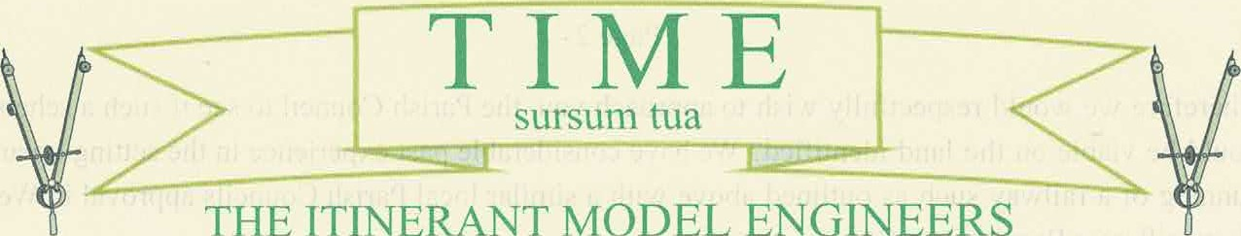THE ITINERANT MODEL ENGINEERS
A Refined Society for the Confused and Confounded Model Engineer
Member of The Northern Association of Model Engineers. Registration No 252
Reply to: - Mr G Stait
88 Stoddens Road
Burnham on Sea
Somerset TA8 2DD

For The Attention of the Chairman and Clerk. Maiden Bradley Parish Council
May we introduce ourselves.We are members of a small society of model engineers primarily interested in the construction and running of miniature steam locomotives of which many examples may be seen in public parks around this country and often taking passengers for short pleasure rides.
We used to run from Easter to the end of October. We were based on a council managed recreation ground for over 50 years. However, through a change in circumstances we decided to leave and form our own society. We have a membership of some 24 plus members to date. Our youngest member is just 21 years old and builds radio controlled lorries and has her own fraction engine.
We formed our thriving society two years ago and hold regular monthly meetings (pre Covid restrictions), as well as organising trips to other societies on a social basis and to run our locomotives on their tracks. As such we have been actively looking for a suitable piece of land to possibly lease and on which to build our own miniature railway.
After visiting a member of our society in Maiden Bradley, Mr. Simon Wager, in order for him to carry out safety tests on our locomotives' (Boiler Tests) for insurance purposes, four members of the club including myself took the opportunity to walk around the village and came across the recreation ground at the top end of the village.
After a discussion between ourselves it became apparent that a section of the recreation ground towards the left of the entrance that is only grassed over, if made available may be an ideal site to place a miniature railway that would not only suit our requirements but also be beneficial to the local residents in terms of recreation and interest value.
Such an amenity is often greatly enjoyed by children accompanied by their parents while having train rides. The engine drivers also appreciate having a "real load" for their locomotives to pull around such a track!
Page 2
Therefore we would respectfully wish to approach you, the Parish Council to see if such a scheme could be viable on the land identified? We have considerable past experience in the setting up and running of a railway such as outlined above with a similar local Parish Councils approval in West Huntspill near Burnham on Sea.
We can assure you that should we be granted the opportunity to meet with you, we would be only too pleased to submit drawing details and proposals and submit outline drawings of track detail and track plan "at no cost to the Council or public"
We feel it would be an asset to the village and you can be assured that we would look after the railway to the high standard already in place for the rest ofthe recreation area.
We would therefore gratefully await further consideration of our proposal, and would be more than happy to answer questions to discuss the mutual benefits of such a scheme.
Yours faithfully
Geoffrey Stait
The Itinerant Model Engineers
cc. M Bennett
R Liddle
M Herrin

