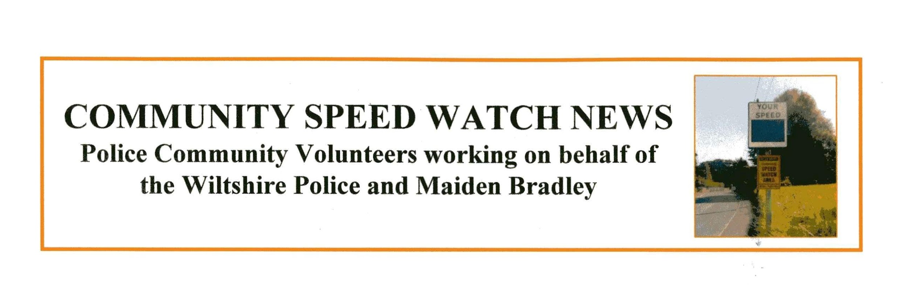
Welcome to Community Speed Watch News, September Issue, compiled and produced by the Maiden Bradley Community Speed Watch Volunteers to keep the village aware of our activities. Also an update on the Frome Road improvement and 20mph High street projects

The three new CSW members are active with the rest of the teams.
Activity, good as usual this month, although only 6 sessions with 1021 vehicles counted and 71 vehicles logged for speeding. Again one in excess of 50mph

The level of aggression and abuse towards CSW members is on the increase right across Wiltshire.

The problem area, Frome Road (B3092) and Church Street are suffering the same problems as always.
We continue to share the Speed Device with the Deverills CSW team. They suffer the same problems as we do.

SID. The Speed Indicator Device. A second SID has been proposed and quotations are being sought.

Simon Wager

Simon Wager. Community Speed Watch Co-ordinator.
Chairman Maiden Bradley Parish Council

